

**__________________________________________________________**



**Group 22**

|  |  |  |
| --- | --- | --- |
| **Students Names and Student Numbers:** | Aditya Suhane | 24212188 |
| Rajalakshmi Sathyamurthy | 24209320 |
| Mallika Nair | 24209537 |
| Orla Conlon | 24297856 |
| Yan Yang | 24218690 |
| Tobias Mella Lukacs | 24273004 |
| **Assessment Title:** | Valuation Report - Bath & Body Works Inc. | |
| **Module Code:** | FIN42030 | |
| **Module Title:** | Financial Analysis 2024/25 | |

**Declaration of Authorship:** We declare that all materials included in this assessment is the end result of our own work and that due acknowledgement has been given in the bibliography and references to ALL sources, be they printed, electronic or personal.

Signed:

|  |  |
| --- | --- |
| Aditya Suhane |  |
| Rajalakshmi Sathyamurthy |  |
| Tobias Mella Lukacs |  |
| Mallika Nair | Minna Mallika Nair |
| Yan Yang |  |
| Orla Conlon | Orla Conlon |

**TABLE OF CONTENTS**

**Basis for Conclusions** **4**

**ABOUT THE COMPANY** **5**

Timeline of the Company 5

Business Segments, Global Presence and Operational Focus 5

Stock Split and Internal Management Changes 6

GROWTH STRATEGIES 6

POTENTIAL RISKS: 7

ACCOUNTING STANDARDS 7

INDUSTRY OVERVIEW: 8

COMPETITIVE POSITIONING 8

**FINANCIAL ANALYSIS** **9**

**VALUATION** **10**

**FORECASTING:** **11**

1. Revenue Growth 11

2. WACC - Weighted Average Cost of Capital 12

3. Interest expense 14

4. Capex and Depreciation 14

5. Cost of Sales and Operating Expenses 14

6. Tax Rate 14

7. Non-Operating Expenses : 14

**SCENARIO & SENSITIVITY ANALYSIS** **15**

Components used as variables: 15

Inferences: 17

**Reference list** **17**

**Does the stock market predict real activity? Time series evidence from the G-7 countries**

# Introduction

**Project Overview**

The objective of this project was to replicate the research paper "Does the Stock Market Predict Real Activity? Time Series Evidence from the G-7 Countries." In this study, we explored the relationship between industrial production (IP) and stock returns for G-7 countries. We implemented our analysis across three different time frames: monthly, quarterly, and annual data. The project involved the application of three types of models: a standard linear regression model, a lagged ECM (Error Correction Model), and ARIMA and GARCH models to predict industrial production growth.

This replication study provided valuable insights into the interplay between stock market performance and real economic activity, as outlined in the original research.

**Paper Selection**

The reason for selecting this research paper was to study the relationship between various factors that contribute to predicting industrial production. Additionally, it aimed to explore how industrial production is influenced by these factors, given its significance as a key indicator for forecasting the growth patterns of any nation.

We chose this paper to leverage data and predictions for the G-7 countries, as this group represents some of the world’s largest economies. Analyzing patterns across these nations provides valuable insights that can be applied to a significant portion of the global economy. This paper also employs various time series models for prediction, offering a diverse perspective and enriching our understanding of industrial production.

The original paper analyzed data from 1950 to 1990; however, due to data constraints, we adjusted the timeframe for our predictions to 2005–2021. Beyond this, a significant reason for this change was to examine how these predictive models perform with modern data, thereby testing the applicability of older models in a contemporary context.

We used three different datasets for our predictions: Industrial Production, Stock Price Index, and Consumer Price Index for the respective G-7 countries, including Japan, Canada, the USA, the UK, Germany, France, and Italy.

# Data Collection

### Data Source

The dataset consists of monthly observations of the Stock Index, Industrial Production Index, and Consumer Price Index for all G-7 countries. The stock index data, which varies by country, was collected from Refinitiv and TradingView. The abbreviations for the respective indices are:

* **Canada:** S&P/TSX
* **USA:** NASDAQ
* **UK:** FTSE 100
* **Japan:** Nikkei 225
* **Italy:** Italian FTSE
* **France:** CAC 40
* **Germany:** DAX

The Industrial Production Index and Consumer Price Index were sourced from the International Financial Statistics provided by the International Monetary Fund (IMF).

The time period for all data samples is one month, and the data was converted into yearly and quarterly observations as required for different calculations and analyses.

**Data Description**

In our analysis, we primarily focus on two main variables: the Industrial Production Index and the Nominal Stock Index. The Real Stock Index is calculated by dividing the Nominal Stock Index by the Consumer Price Index. This step is a critical aspect of our predictive model, as it adjusts the stock index for inflation, ensuring that our predictions are based on real, inflation-adjusted values rather than nominal figures.

**Source:Own Elaboration**

In the above plot, we can observe the trend of the Industrial Production Index for all G-7 countries over the time frame from 2005 to 2020. The countries are represented using the following color scheme: France in blue, Germany in orange, Italy in green, Japan in red, the UK in purple, the USA in brown, and Canada also in purple.

*Source : Own elaboration*

The above graph shows the trend lines of consumer price index over a time frame of 2005 to 2020.

In the above graph, we can observe the actual price index for all the major G-7 economies. This index is calculated by dividing the real stock index by the consumer price index. Most countries follow a relatively stable trend with minimal volatility. However, the Italian and Japanese stock indices stand out, exhibiting distinct behavior compared to others after the conversion to the actual price index. This divergence might play a critical role in the prediction of the Industrial Production Index.

In every model we use, we have applied the log growth rate for both industrial production and the real stock index. Additionally, we have handled missing data by dropping all null values in our predictive analysis. One of the key challenges faced was the conversion of the date-time format, which we successfully addressed. We also combined all the datasets into one unified dataframe. To handle different time frames, we converted the monthly data into yearly and quarterly data using the mean method.

## GROWTH STRATEGIES

First, we performed the Augmented Dickey-Fuller (ADF) test for each of the G-7 countries. The ADF test was conducted to determine whether the data is stationary or non-stationary, which is a crucial step for ensuring the stationarity of the data. In the ADF test, the null hypothesis is that the data is non-stationary, while the alternative hypothesis is that the data is stationary. A stationary data series is one where the mean, variance, and autocorrelation remain constant over time. We conducted the ADF test on the differences in log returns of industrial production and stock indices for each of the countries.

*Ho: Data points are non – Stationary*

*H1: Data points are Stationary*

Source :

In the above Augmented Dickey-Fuller (ADF) test, we conducted the test on the monthly data for the Canadian Stock Index and the Industrial Production Index. The p-value obtained from the test was very low, indicating that we can reject the null hypothesis, which suggests that the data is non-stationary. Therefore, we accept the alternative hypothesis, which states that the data is stationary. This is a crucial step, as stationarity is required for the validity of subsequent time series models.

Source:

In the above ADF test, we conducted the test on the US Stock Index (Nasdaq) and the Industrial Production Index. The results show that both the US Stock Index and the Industrial Production Index are stationary, as we were able to reject the null hypothesis that suggests the data is non-stationary. This indicates that the data is suitable for further analysis, and we can proceed with time series modeling for prediction purposes.

Source:

Same goes with the French index, which is the **CAC-40**. The Augmented Dickey-Fuller (ADF) test conducted on the French Stock Index (CAC-40) and the Industrial Production Index shows that both are stationary.

Source:

Same goes for the German index, which is the **DAX**. The Augmented Dickey-Fuller (ADF) test conducted on the German Stock Index (DAX) and the Industrial Production Index shows that both are stationary

Source:

Same goes for the Japanese index, which is the **Nikkei 225**. The Augmented Dickey-Fuller (ADF) test conducted on the Nikkei 225 Stock Index and the Industrial Production Index shows that both are stationary.

Source:  
The same applies to the UK **FTSE 100** index as well. The Augmented Dickey-Fuller (ADF) test conducted on the FTSE 100 Stock Index and the Industrial Production Index shows that both are stationary.

Source:

The same goes for the **Italian FTSE** index as well. The Augmented Dickey-Fuller (ADF) test conducted on the Italian FTSE Stock Index and the Industrial Production Index shows that both are stationary.

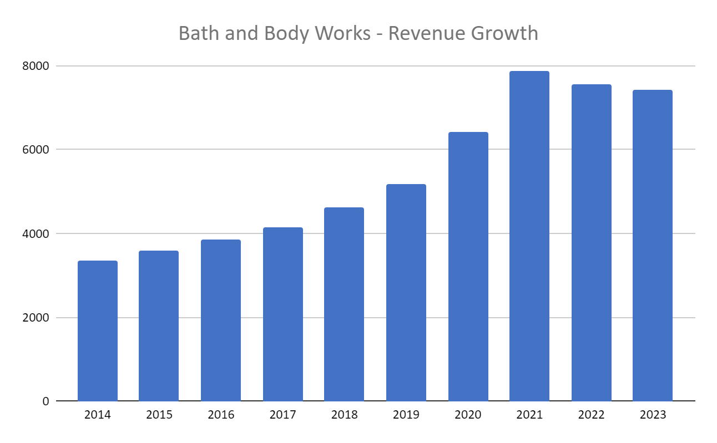

*Source : Revenue data from BBW annual reports and Bloomberg.*

## POTENTIAL RISKS:

We **categorised the risks into two areas**:

* **Industry - Specific Risk** - **Inflation and geo-political risk** As a consumer cyclical speciality retailer, BBWI is exposed to the risks of this sector. Consumer demand is seasonal and can decline in unfavourable economic conditions like higher inflation rates, as seen in 2022 and 2023. BBWI has relied heavily on their in-store experience. Net sales are dependent on the customer footfall in physical stores, and the sustainability of their leased spaces poses a potential area for losses. As an international business, the company is exposed to foreign exchange risk, geopolitical situations and global supply chain issues. Crucially, the competitive nature of the retail industry indicates fierce price competition and necessitates investment in product innovation, branding and marketing.
* **High level of Debt leverage:** The recent trend of turnovers in the company’s key leadership positions and instances of shareholder activism could extend into the future. Given the high level of leverage, debt repayment and refinancing are ongoing challenges for BBWI.

## ACCOUNTING STANDARDS

The company follows the U.S. GAAP accounting principles and publishes annual reports, quarterly results and SEC filings. Their fiscal year ends on the Saturday closest to January 31st (BBWI Form 10-K 2024).

## INDUSTRY OVERVIEW:

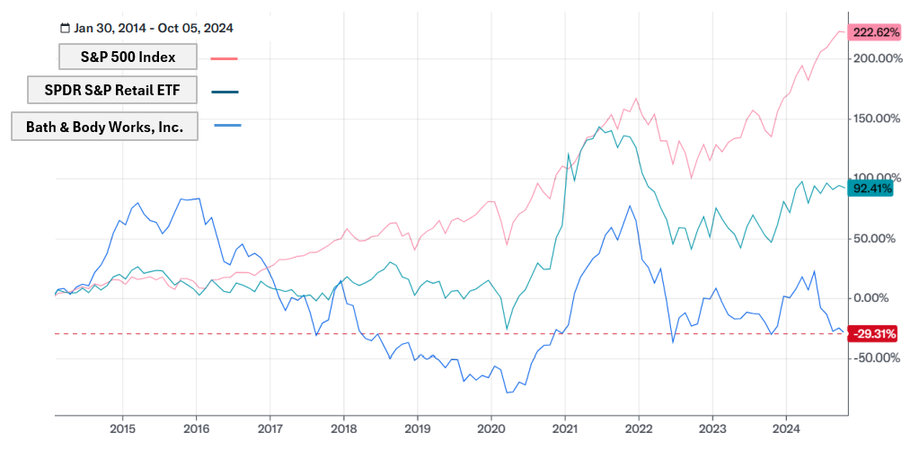

*Source : Own elaboration per Yahoo Finance*

In the graph above, we have compared the past ten years of returns of BBWI with the S&P 500 index and the SPDR S&P Retail ETF, which tracks the performance of the retail segment of the total market index. (Graph created on Yahoo!Finance.com). As of 1 October 2024, BBWI moved out of the S&P 500 index to the S&P SmallCap 600 (News Release Archive, 2024)

## COMPETITIVE POSITIONING

In our peer analysis, we focused on Bath & Body Works' leverage relative to its competitors. While the company's profit margins align with those of its peers and the industry, it exhibits an anomaly in terms of leverage. Comparing average key metrics over 2019- 2024, **the abnormal leverage ratios of BBWI, due to high level of indebtedness and negative equity, are highlighted**. (“Peer Metrics” tab in Group_22_Valuation_BBW.xlsx, Data Source: Yahoo!Finance.com, Eikon.Refinitiv.com).

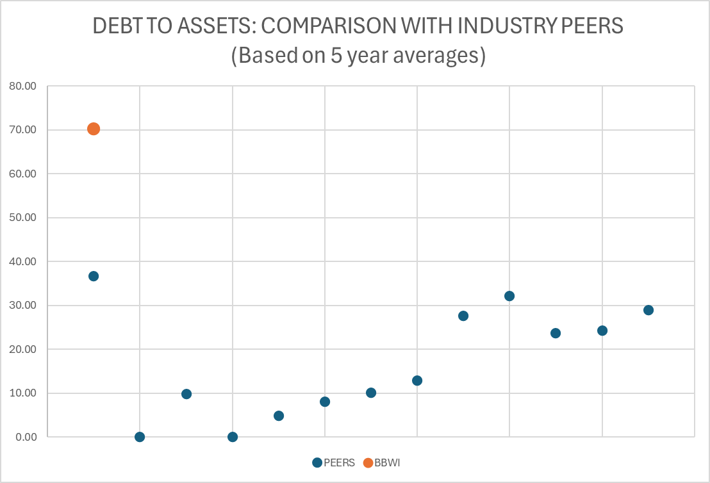

*Source : Own elaboration*

Our analysis of the annual SEC filings showed that, post the Victoria’s Secret spinoff, BBWI has had several strategy shifts (such as more off- mall retail spaces) and investments (such as the IT Transformation Project), which have required capital expenditure, resulting in high accumulated levels of long-term debt. This can be interpreted as a leveraged growth strategy by BBWI to recapture their position in specialty retail.

**Reducing Leverage** : The company repaid 447 million USD worth of long-term debt in 2023- 24 and their Debt/ EBITDA level has reduced from 2020 (www.sec.gov, n.d.). Through analysis of their annual reports - we can reasonably expect the company to continue to lower its debt to reach industry normative levels.

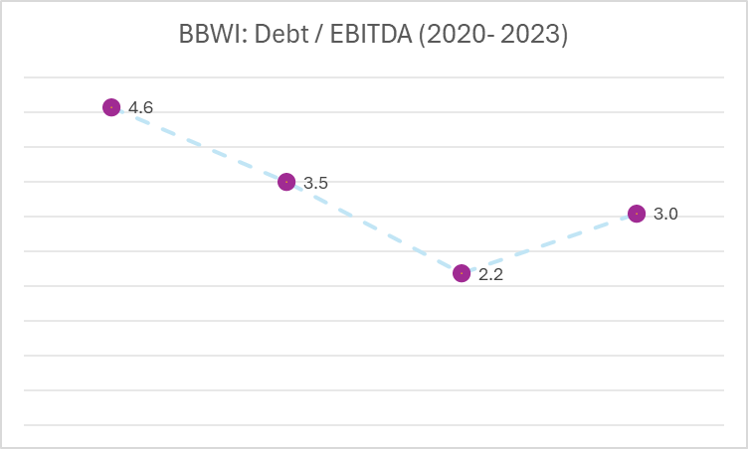

*Source : Own elaboration*

# FINANCIAL ANALYSIS

* **Revenue** grew from $3.3 billion in 2014 to $7.4 billion in 2023, with an average annual increase of 5.66%. The pandemic years of 2020 and 2021 were outliers, with a 24% revenue surge driven by increased consumer focus on skincare and personal care products as self-care gained importance
* **Segment-wise revenue** - The surge in revenue in 2020 and 2021 for hand-sanitisers has started to reduce post pandemic, but the growth in men’s skincare has increased thereby leading to overall increase in Net Sales.
* **P/E Multiple** : The company has demonstrated stable, moderate growth, with its P/E multiple ranging between 11 and 14. However, there was a drop in the P/E multiple from 2022 to 2023 due to a decline in profits driven by inflation, which increased the costs of raw materials, transportation, and labour.

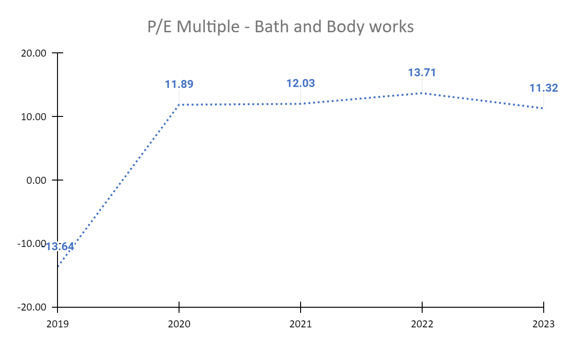

*Source : Own elaboration*

* **Capital Expenditure- IT Systems** : Company spent $164 million on **capital expenditure**  to build new IT systems that would separate it from the IT system of Victoria’s secret , thereby supporting distribution and logistics capabilities that would result in long term-growth.
* **Favourable Current Ratio** : The company has been consistently maintaining a favourable current ratio ( above 1). It was increased from 1.37 in 2019 to 1.64 in 2024. This is in-line with the industry and its peers.
* **Reduction in Net Profit Margin** : Due to an increase in debt and rising costs from inflation, the company's net profit margin has **decreased from 17% to 12%**.
* **Focus on increasing profitability and shareholder Value :** Amid the transition to a standalone company, the company has maintained a consistent dividend payout ratio of 20%. The company is currently focusing on reducing its debt in the capital structure, building IT systems to enhance its online presence and develop a separate infrastructure from Victoria’s Secret, **increasing its focus on profitability and shareholder value.**

# 

# VALUATION

For the valuation of BBW free cash flows are projected over 10 years and discounted to their present values. Beyond this explicit projection period, a terminal value is used to account for future and long term cash flows. The weighted average cost of capital (WACC), incorporates cost of debt and cost of equity, used as the discount rate. WACC reflects the company’s capital structure and includes the tax benefits of debt in the discount rate rather than the cash flows. WACC is the rate at which a company’s total free cash flows are discounted to determine its overall value (Damodaran, 2002).

# FORECASTING:

## Revenue Growth

Bath & Body Works (BBW) separated from Victoria’s Secret as a standalone company post-2021. To forecast its revenue, we analysed the company’s annual reports from 2014 for BBW specific revenues . Revenue spiked in 2020 and 2021 due to increased demand for skincare products during the pandemic. To ensure accuracy, we excluded these outlier years. The average historical YoY growth rate calculated was 5.66%, while the specialty retail industry grew at 2.38%. Given rising consumption trends and BBW's Capex growth, we forecasted revenue using a blend of historical and industry growth rates:

|  |  |
| --- | --- |
| 2024 to 2028 | $r_{g}= \frac{2}{3}⋅r_{Historical Growth}+\frac{1}{3}⋅r_{Industry Growth}$ $$r_{g}=\frac{2}{3}⋅5,66\% + \frac{1}{3}⋅2.38\%$$ $r_{g}=$**4.56%** |
| 2029 to 2033 | Projected as a decreasing **average** between the forecasted revenue until 2029 and the continuing value. |
| Continuing Value | Given the GDP is expected to grow at an average of 1.8% ( published by cbo.gov.in), the continuing value has been at **1.5%** for the company’s growth. |

**Revenue growth - Sensitivity Analysis**

We further used the **1/9th sensitivity adjustment rule**, to predict the best case and worst case growth rates.

|  |  |  |  |  |  |  |  |
| --- | --- | --- | --- | --- | --- | --- | --- |
|  | **2024 to 2028** | **2029** | **2030** | **2031** | **2032** | **2033** | **Continuing Value** |
| **Best Case** | **5.07%** | 4.36% | 3.64% | 2.93% | 2.21% | 1.50% | 1.50% |
| **Base Case** | **4.56%** | 3.95% | 3.34% | 2.73% | 2.11% | 1.50% | 1.50% |
| **Worst Case** | **4.06%** | 3.55% | 3.04% | 2.52% | 2.01% | 1.50% | 1.50% |

*Source : Own elaboration*

## WACC - Weighted Average Cost of Capital

A WACC of 8.33% was calculated for August 2nd, 2024 (please refer to tabs 4.1 WACC and 4.2 Beta BBW in the Excel file).

**Formula**:

$$WACC= r_{kb}⋅(1-T)⋅\frac{Debt}{(Debt+Equity)}+r_{kp}⋅\frac{Equity}{(Debt+Equity)}$$

**Components of WACC calculation:**

To arrive at the WACC figure of 8.33%, we calculated the below data:

|  |  |  |
| --- | --- | --- |
|  | **Forecast** | **Calculation** |
| Target Debt-to-Equity ratio | 31.66% Debt  68.34% Equity | The target debt-to-equity ratio of 46.34% reflects the company’s target debt-to-equity ratio and complies with the firm's capital policy as described in the annual report. The assumption is that they will keep reducing their debt until 2029 (FY28). |
| Cost of Debt | 6.6% | This is the YTM of the latest bond that BBW issued. The 6.625% fixed interest rate notes due October 2030 issued by Bath & Body Works is a bullet bond  For the fiscal year ending February 2024, the company reported a debt leverage ratio of 2.8, down from 3.1 the previous year. This debt leverage ratio has been influenced by BBWI retaining Victoria Secret's debt following the split of the companies. As per the annual report, BBWI plans to repay this debt. Accordingly, the debt ratio of the company will be drastically reduced within the next 5 years, with a slight increase for the following 4 years. |
| Beta of debt | 0.53 | This was calculated based on the following formula (please refer to Excel tab 4.1). The current risk-free rate of a US 10Y Treasury Bond on the 2nd of August is 3.76%, and the market risk premium per Statista for 2024 in the US is 5.5%. $$K_{b}=R_{f}+β_{d}⋅MRP$$ $$β_{d}=\frac{K_{b}-R_{f}}{MRP}$$ |
| Adjusted Beta of equity | 1.2 | Using OLS regression, and the stock prices of S&P 500 index and Bath and Body works over the last 2 years, this was calculated. ( 502 observations in total and R-square at 20%) $$β_{adjusted}=(\frac{1}{3})+β*(\frac{2}{3})$$ |
| Unlevered Equity Beta | 0.94 | Using a corporate tax rate of 21% for the US ( Federal tax rate) and the average debt-to-equity ratio of the past 4 years: $$β_{p}^{\frac{c}{d}}=β_{p}^{\frac{s}{d}}⋅\left[1+\left(1-t_{c}\right)⋅\frac{B}{P}\right]-β_{d}⋅\left(1-t_{c}\right)⋅\frac{B}{P}$$ $$β_{p}^{\frac{s}{d}}=\frac{{β_{p}^{\frac{c}{d}}+{β_{d}⋅\left(1-t_{c}\right)⋅\frac{B}{P}}_{}}_{}^{}}{1+\left(1-t_{c}\right)⋅\frac{B}{P}}$$ |
| Cost of Equity | 9.74% | Calculated using the CAPM formula: $$K_{P}=R_{f}+β_{p}^{\frac{c}{d}}⋅MRP$$ |

However, if the target capital structure changes, we get a different WACC, as shown in the table below:

|  |  |  |  |  |  |  |  |  |
| --- | --- | --- | --- | --- | --- | --- | --- | --- |
| **Calculation of Cost of Capital for Bath and Body Works.** | | | | | | | | |
|  | **Cost of Debt** | **Tax** | **Unlevered Beta** | **Levered Beta** | **Debt Ratio** | **Equity Ratio** | **Cost of Equity** | **WACC** |
| **Base Case** | **6.7%** | 21.0% | **0.94** | **1.09** | **31.66%** | 68.34% | **9.7%** | **8.33%** |
| **Increase in Equity** | **6.7%** | 21.0% | **0.94** | **1.03** | **22.22%** | 77.78% | **9.4%** | **8.51%** |
| **Increase in**  **Debt** | **6.7%** | 21.0% | **0.94** | **1.19** | **44.44%** | 55.56% | **10.3%** | **8.09%** |

*Source : Own elaboration*

## Interest expense

Forecasted using the 10-year interest payment forecast based on Bath & Body Works' issued notes. The forecast reflects expected annual interest payments for each year from 2024 to 2033. The payments decrease as various bonds mature over the period, leading to a reduction in the total interest obligations.

## Capex and Depreciation

Per company’s annual report of 2023, There will be no major capital expenditures within the next 10 years. As described in the company overview, BBW's predominant strategy is to decrease its stores and increase its online sales. There will be no major depreciation changes throughout the forecasted years, so there will be no major changes in long-term assets.

## Cost of Sales and Operating Expenses

Forecasted using the historical average of cost of sales and expenses over the last 5 years.

## Tax Rate

The current federal tax rate of 21% was used in the forecast calculation.

## Non-Operating Expenses :

Non operating income/expenses is not related to the core business of BBW and we will therefore establish 0$ projected to the future

**ANALYSIS AND RECOMMENDATION**

Based on the forecasted figures, we calculated the Enterprise Value to be $13,957 million, which translated to a share price of **$36.18** (FCFF) and **$39.31** (FCFE). Bath and Body Works Inc.’s stock price is **$33.20** ( August 2024 - post Q2 results). Both our valuation models indicate that the stock is undervalued. This is because of :

* Consistent revenue growth at 5.66% over the past 10 years.
* Growth in net profit margin by 10% post the separation into a standalone company
* Stable dividend payout ratio at 20%
* Management’s strategic focus on controlling costs and inefficiencies.
* Bath & Body Works' current and future strategy emphasizes enhancing IT systems and expanding its online presence to boost revenue, along with reopening off-mall stores, all of which indicate strong potential for future growth.
* Given the company’s increased focus on reducing its debt in the capital structure, we have forecasted to reduce their debt by 11% YoY, thereby increasing their profitability and subsequently the shareholder value.

Therefore, based on our valuation model, we recommend buying Bath and Body Works stock.

# 

# 

# 

# 

# 

# 

# 

# 

# SCENARIO & SENSITIVITY ANALYSIS

We performed a scenario analysis to determine how sensitive is the final value of the firm per share for change in Revenue Growth rate, WACC and Cost of Equity.

## Components used as variables:

To conduct this analysis, we varied two key components: **Revenue** and **WACC**.

1. **Revenue** : The baseline forecasted revenue growth is 4.56%. Using a 1/9th sensitivity adjustment model, we evaluated an optimistic (best-case) scenario with a growth rate of 5.07% and a pessimistic (worst-case) scenario with a growth rate of 4.09%.
2. **Capital Structure and Levered Beta**: In our analysis, we explored two additional scenarios: one with an increased proportion of equity, and another with an increased proportion of debt ( as mentioned below).

|  |  |  |  |  |  |
| --- | --- | --- | --- | --- | --- |
| **Calculation of Cost of Capital for Bath and Body Works.** | | | | | |
|  | **Levered Beta** | **Debt Ratio** | **Equity Ratio** | **Cost of Equity** | **WACC** |
| **Base Case** | **1.09** | **31.66%** | **68.34%** | **9.7%** | **8.33%** |
| **Increase in Equity** | **1.03** | **22.22%** | **77.78%** | **9.4%** | **8.51%** |
| **Increase in Debt** | **1.19** | **44.44%** | **55.56%** | **10.3%** | **8.09%** |

*Source : Own elaboration*

**Calculation**:

**Free Cash Flow to Firm:**

|  |  |  |  |  |  |
| --- | --- | --- | --- | --- | --- |
|  |  | | **Riskier Scenario** | **Standard** | **Favourable Scenario** |
| **Calculation of Cost of Capital for Bath and Body Works.** | | | | |
| **FCFF** | **WACC** | | | |
| **Revenue**  **Growth Rate** |  | **8.51%** | **8.33%** | **8.09%** |
| **Worst Case** | **4.06%** | **$ 33.65** | **$ 35.20** | **$ 37.40** |
| **Base Case** | **4.56%** | **$ 34.59** | **$ 36.18** | **$ 38.42** |
| **Best Case** | **5.07%** | **$ 35.57** | **$ 37.18** | **$ 39.47** |

*Source : Own elaboration*

**Free Cash Flow to Equity:**

|  |  |  |  |  |  |
| --- | --- | --- | --- | --- | --- |
|  |  | | **Favourable Scenario** | **Standard** | **Riskier Scenario** |
| **Calculation of Cost of Capital for Bath and Body Works.** | | | | |
| **FCFE** | **Cost of Equity** | | | |
| **Growth Rate** |  | **9.40%** | **9.70%** | **10.30%** |
| **Worst Case** | **4.06%** | **$ 40.05** | **$ 38.20** | **$ 34.88** |
| **Base Case** | **4.56%** | **$ 41.46** | **$ 39.31** | **$ 36.09** |
| **Best Case** | **5.07%** | **$ 42.93** | **$ 40.93** | **$ 37.35** |

*Source : Own elaboration*

## Inferences:

1. As the equity increased in the capital structure, the WACC increased from 8.33 to 8.51%. A higher WACC leads to a lower price in share. This is because the returns are discounted at a higher rate, thereby reducing the present value of the future cash flows.
2. The most favourable scenario is at the best case revenue growth at 5.07% and the lowest WACC at 8.09% which signifies a higher debt in the capital structure at 44% compared to the base case scenario of 31%.
3. As the company aims to reduce its overall debt, currently at 138% of its capital structure, it can maintain a debt level between 36% and 44% to achieve a more optimal WACC.

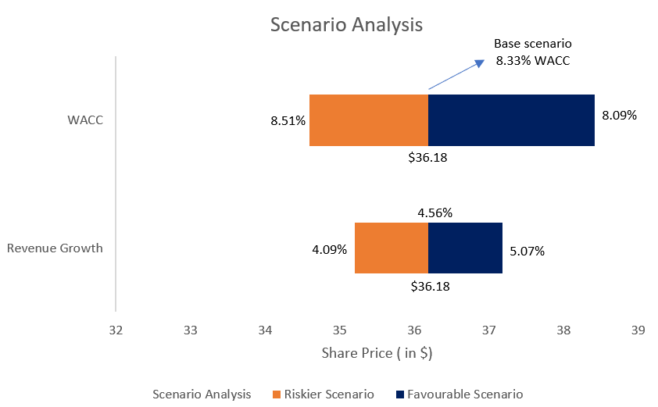

*Source : Own elaboration*

# Reference list

1. Income Statement, Balance Sheet of Bath and Body Works - Bloomberg
2. GDP Growth Rate : <https://www.cbo.gov/publication/58957>
3. Specialty Retail Industry Growth Rate : <https://csimarket.com/Industry/industry_growth_rates.php?ind=1307>
4. Market Price for calculating P/E Multiple : https://finance.yahoo.com/quote/BBWI/history/
5. Adams, J. (2024). *Bath & Body Works: My Top Turnaround Stock Going Into 2025*. [online] Seeking Alpha. Available at: https://seekingalpha.com/article/4721659-bath-and-body-works-my-top-turnaround-stock-going-into-2025.
6. News Release Archive. (2024). *Amentum Set to Join S&P 500; Bath & Body Works to Join S&P SmallCap 600*. [online] Available at: https://press.spglobal.com/2024-09-24-Amentum-Set-to-Join-S-P-500-Bath-Body-Works-to-Join-S-P-SmallCap-600 [Accessed 6 Oct. 2024].
7. www.sec.gov. (n.d.). *EDGAR Entity Landing Page*. [online] Available at: https://www.sec.gov/edgar/browse/?CIK=701985&owner=exclude.
8. Yahoo Finance. (2023). *Newsweek Names Bath & Body Works to List of America’s Best Loyalty Programs*. [online] Available at: https://finance.yahoo.com/news/newsweek-names-bath-body-works-143000136.html.
9. Bath & Body Works (2023a). *About Us - Impacts Through Fragrance*. [online] Bath & Body Works, Inc. Available at: https://www.bbwinc.com/about-us.
10. Bath & Body Works (2023b). *Annual Reports | Bath & Body Works, Inc.* [online] Bath & Body Works, Inc. Available at: https://investors.bbwinc.com/financial-reporting/annual-reports.
11. Bath & BodyWorks (2021a). *Bath & Body Works, Inc. Completes Separation of Victoria’s Secret | Bath & Body Works, Inc.* [online] Bath & Body Works, Inc. Available at: https://investors.bbwinc.com/news-releases/news-release-details/bath-body-works-inc-completes-separation-victorias-secret.
12. Bath & BodyWorks (2021b). *L Brands, Inc. Board Approves Separation of Victoria’s Secret & Co. and Corporate Name Change to Bath & Body Works, Inc. | Bath & Body Works, Inc.* [online] Bath & Body Works, Inc. Available at: https://bbwinc.gcs-web.com/news-releases/news-release-details/l-brands-inc-board-approves-separation-victorias-secret-co-and.
13. Smith , P. (2022). *Topic: Limited Brands*. [online] Statista. Available at: https://www.statista.com/topics/2260/limited-brands/#:~:text=Limited%20Brands%20(L%20Brands)%20was [Accessed 18 Sep. 2024].
14. Weiker, J. (2021). *Timeline: Columbus retail legend Leslie H. Wexner, his life from The Limited to L Brands*. [online] The Columbus Dispatch. Available at: https://eu.dispatch.com/story/business/2021/03/18/timeline-columbus-retail-legend-leslie-les-wexner-limited-l-brands/4746539001/ [Accessed 19 Sep. 2024].

### A. Damodaran (2002). “Investment Valuation :Tools and Techniques for Determining the Value of Any Asset.”

### Bath & Body Works. (2024) *Bath & Body Works reports fourth quarter and full year 2023 results*. Available at:<https://investors.bbwinc.com/news-releases/news-release-details/bath-body-works-reports-fourth-quarter-and-full-year-2023> (Accessed: 4 October 2024).